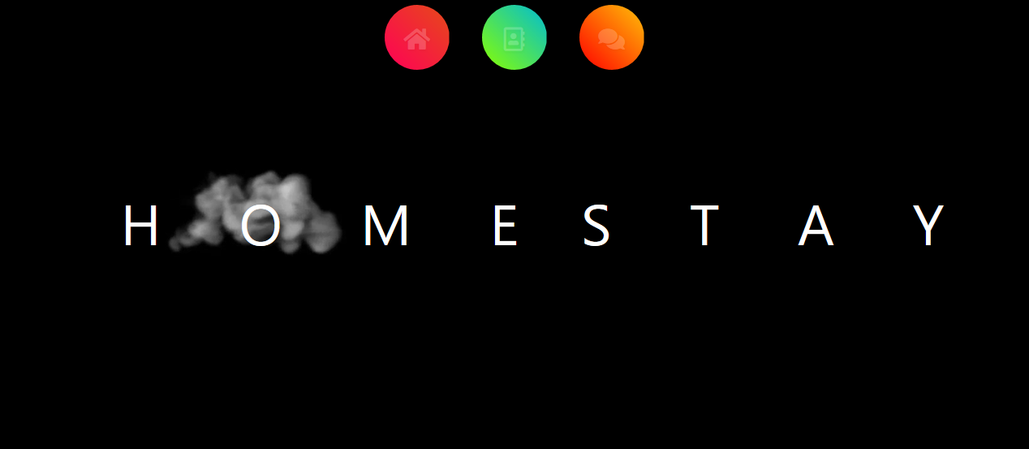

This is home stay page where home stay will show in smoke form and there is 3 icon available of Home , About us , Testimonials.

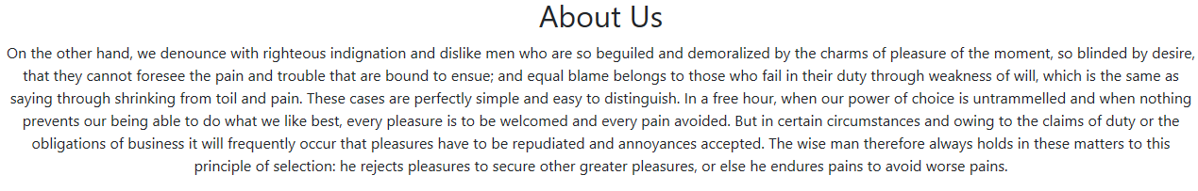

On clicking About us icon it will show about us page..

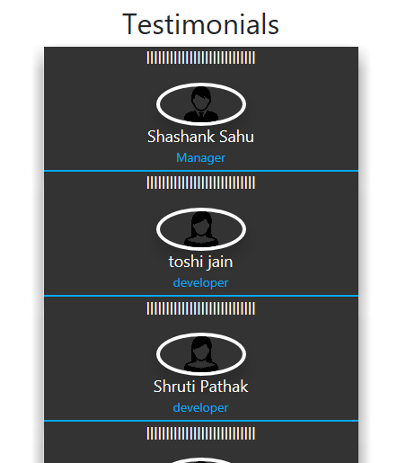

On clicking testimonials icon it will open testimonials page in neon form

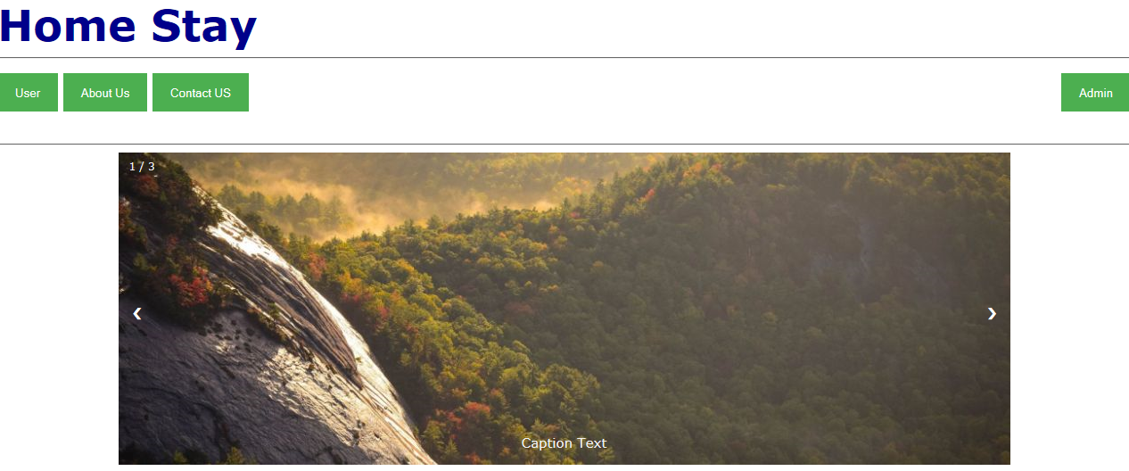

On clicking home icon it will open home page where it will display the pictures in sliding manner.

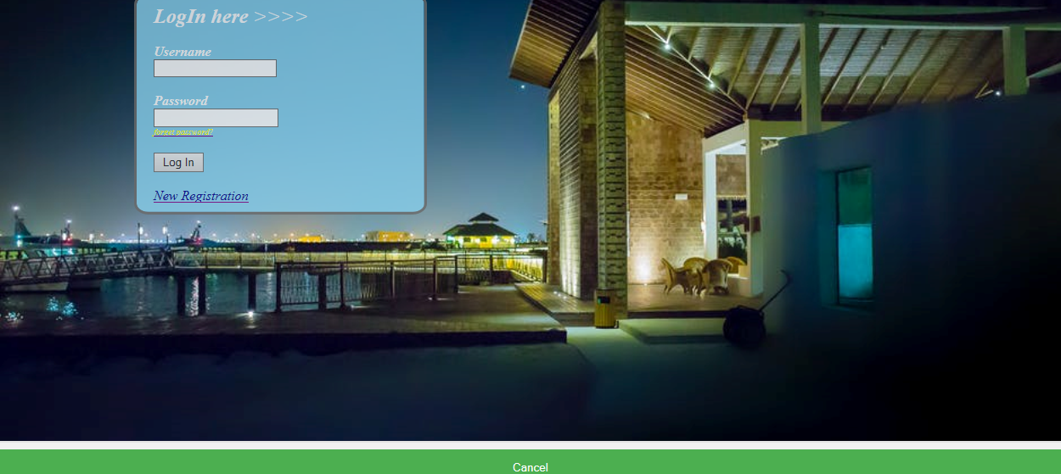

On clicking user icon it will redirect to user login page. If username is invalid then it will blink invalid username.

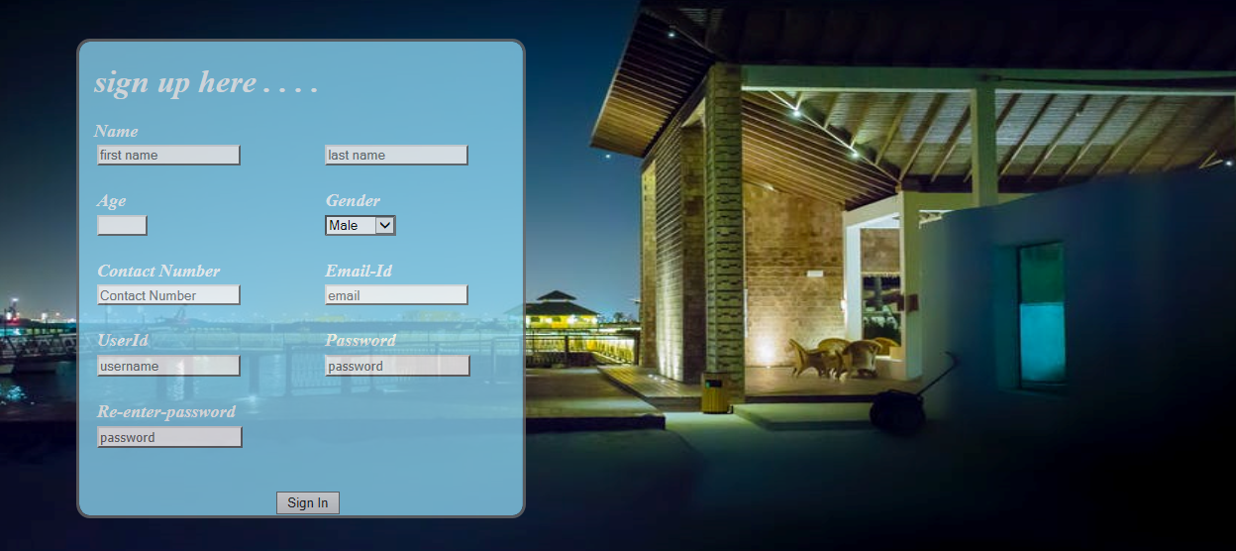

If user is new then click on new registration ,then it will redirect to new registration page..

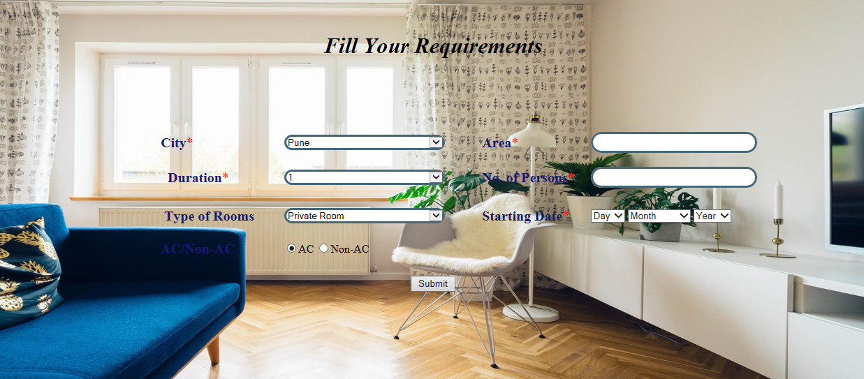

If user is valid then it will redirect to page where user can fill the requirements like area in which they want to stay ,duration,no. of days,type of rooms then submit it.

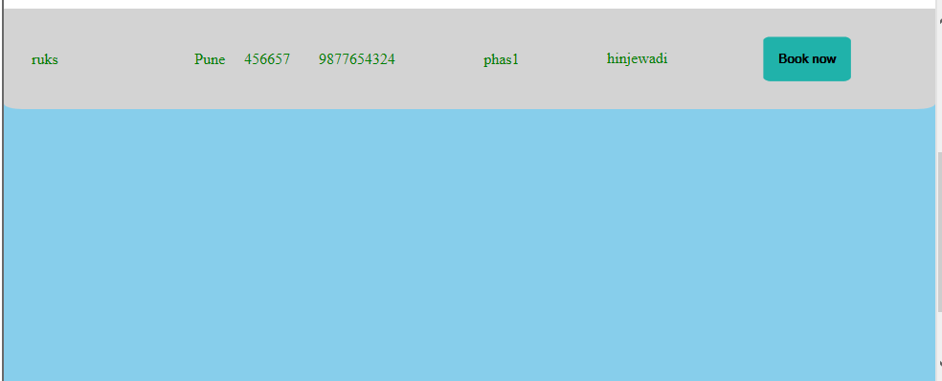

After submitting the requirements then user view page will open where user can be able to book the stay, After booking there will be a pop message which will display message of “successful register the stay”.

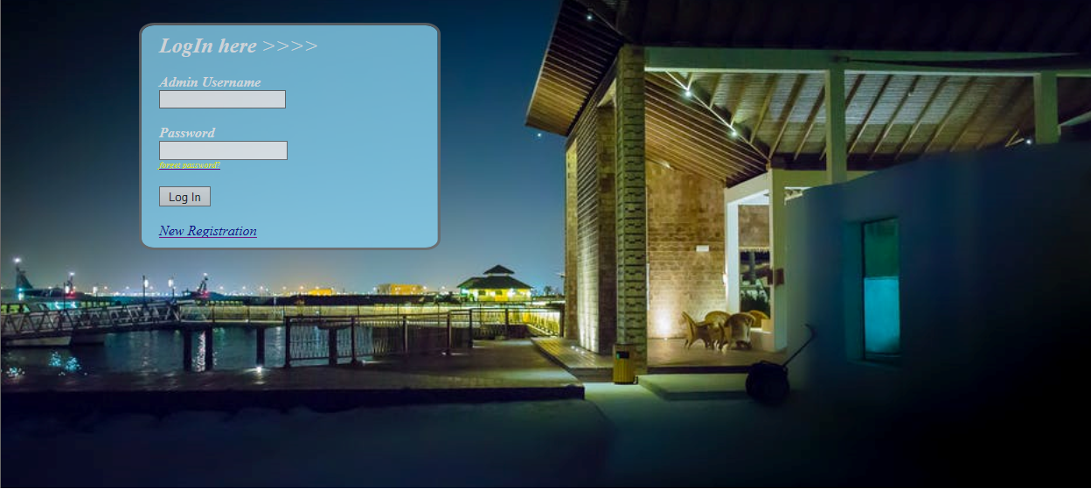

On clicking admin it will redirect to admin login page..

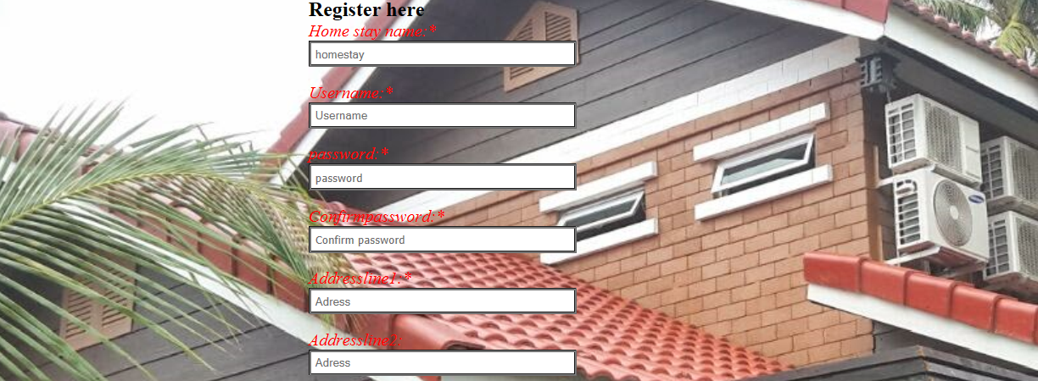

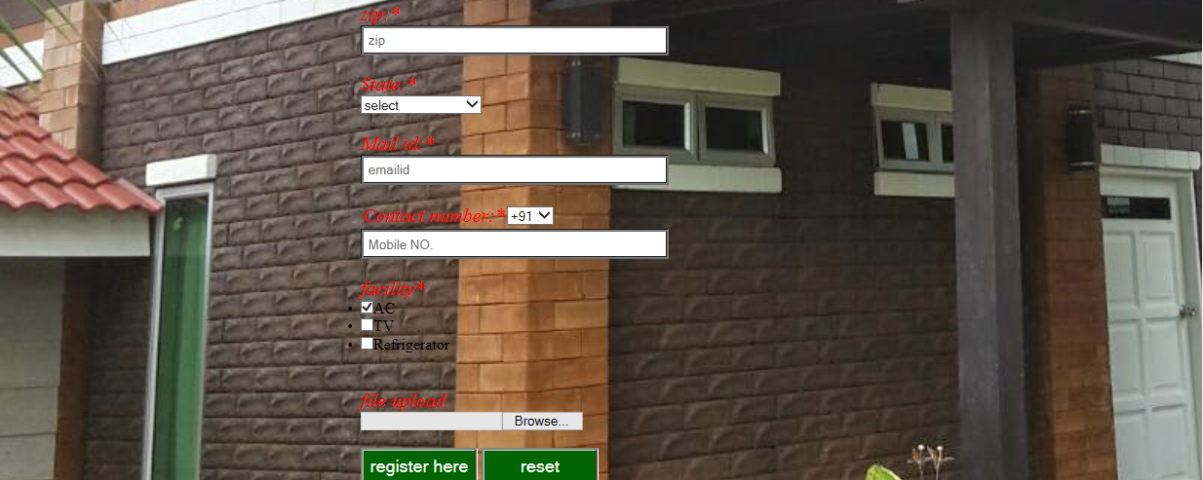

On clicking new registration it will redirect to registration page where confirm password,mobile number and zip validation …

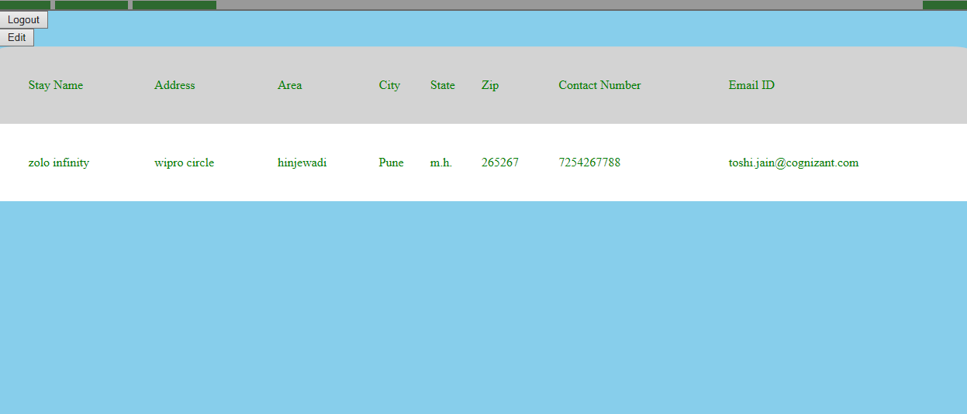

After succesfull login ,admin can get the views of theirs details and they can also able to edit the details ..after all this admin can logout.

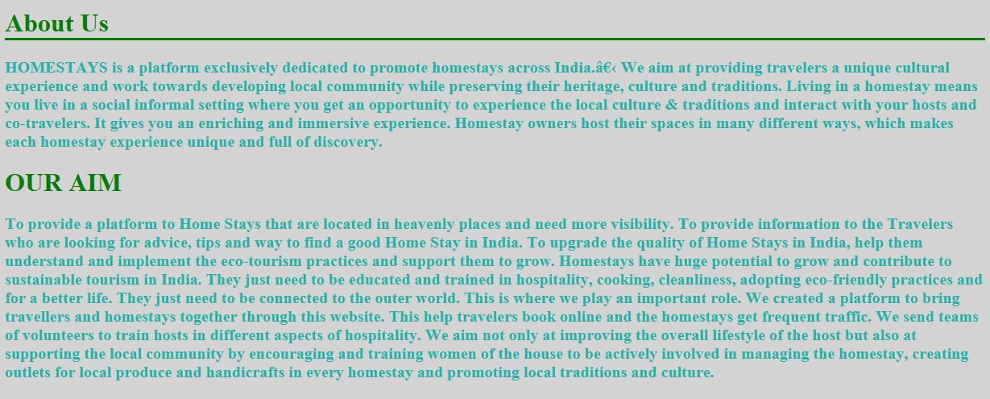

On clicking about us it will show this page.

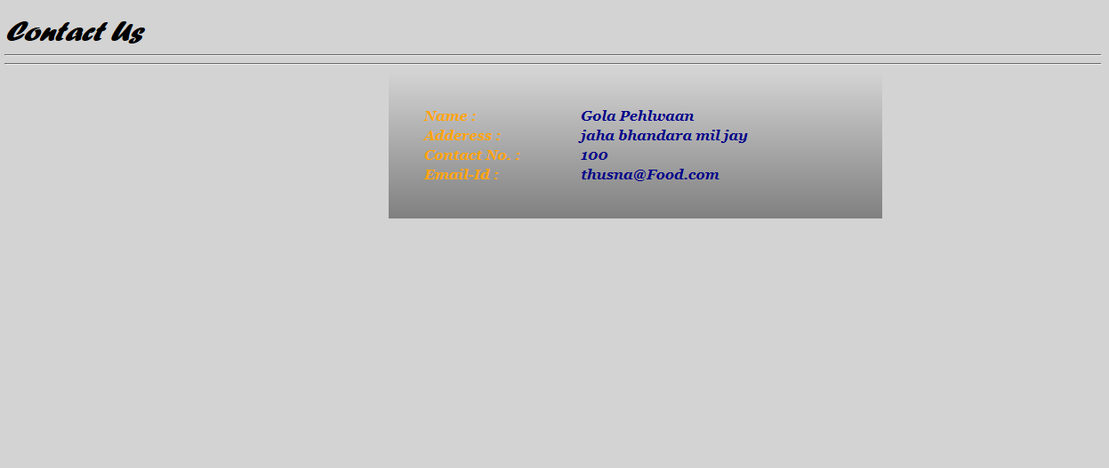

On clicking contact us page it will show contact us page…

